

*Institut spécialisé dans les métiers de l'offshoring Tétouan*

Web applicationfor internships management

Mr. Zayd El Imrani

**Made by:**

**Professional supervisor:**

Mr. Oussama Rahmouni

**Academic supervisor:**

Internship report

Youssef El Aissaoui

2022-2023

*NTT DATA*

# Dedication

To My parents for their sacrifices and encouragement To My family for their love and support,

And to my friends for their encouragement and wishes of success

To all of you,

I dedicate this work.

*Youssef El AISSAOUI*

# Thanks

First and foremost, I would like to express my heartfelt gratitude to Allah for the blessing of life and good health, and for enabling me to complete this work under the best conditions despite all the constraints and obstacles encountered.

I want to express my deep appreciation to my parents for their unwavering love, support, and encouragement throughout this journey. Their belief in me has been a constant source of inspiration.

I would like to extend my sincere thanks to Mr. Oussama Rahmouni for his assistance, support, encouragement, trust, and valuable guidance.

I am also immensely grateful to my supervisors, Zayd El Imrani and Ayoub El Youssoufi, for their guidance, valuable insights, and constant support during my internship. Their assistance and availability have greatly contributed to the success of my project.

Lastly, I am truly grateful to everyone who has contributed directly or indirectly to the success of my project. Your support and contributions have been immensely valuable.

Thank you, Allah, for your blessings, and thank you, my parents, for your unwavering support.

# Abstract

This document is the result of my work as part of my internship project titled "Design and Implementation of an Internship Management Module," which was carried out within the company NTT DATA.

NTT DATA has launched a project called "Enterprise Management System (EMS)" that provides a solution to simplify the recruitment process and internships management for NTT DATA, a multinational specialized in the field of information technology.

The objective of this project is to fulfill the requirements of the Internship Management module through the design and implementation of an application specifically tailored for managing internships.

During this project, our mission was to participate in the entire project development cycle. We adopted an agile planning lifecycle based on the "Scrum" methodology, this approach allowed us to effectively manage tasks, collaborate with team members, and ensure timely delivery of the Internship Management module for NTT DATA's Enterprise Management System.

Regarding the main technical choices, we used Spring Boot for the backend, Angular for the frontend, MySQL for persistence, Git was used for version control, and NTT DATA server for deployment.

**Keywords:**

Enterprise Management System, internships management, E-recruitment, technical training...

# Re´sume´

Ce document est le résultat de mon travail dans le cadre du projet de fin d'études intitulé " Conception et mise en place d'un module de gestion de stage en ligne ", réalisé au sein de l'entreprise NTT DATA.

NTT DATA a lancé un projet appelé "Enterprise Management System (EMS)" qui fournit une solution pour simplifier le processus de recrutement et la gestion des stages pour NTTDATA, une multinationale spécialisée dans le domaine des technologies de l'information.

L'objectif de ce projet est de répondre aux exigences du module de gestion des stages à travers la conception et l'implémentation d'une application spécifiquement adaptée à la gestion des stages.

Au cours de ce projet, notre mission a été de participer à l'ensemble du cycle de développement du projet. Nous avons adopté un cycle de planification agile basé sur la méthodologie " Scrum ", cette approche nous a permis de gérer efficacement les tâches, de collaborer avec les membres de l'équipe et d'assurer la livraison dans les délais du module de gestion des stages pour le système de gestion d'entreprise de NTT DATA.

En ce qui concerne les principaux choix techniques, nous avons utilisé Spring Boot pour le backend, Angular pour le frontend, MySQL pour la persistance, Git a été utilisé pour le contrôle de version, et le serveur NTT DATA pour le déploiement.

**Mots-clés :**

Enterprise Management System, gestion des stages, E-recrutement, formation technique...

# Acronyms

**API** Application Programming Interface

**Auth** Authentication

**CRUD** Create Read Update and Delete

# Contents

Dedication 1

Thanks 2

Abstract 3

Re´sume´ 4

Acronyms 5

Contents 6

Introduction 8

I. Analysis and Concept design 10

I Presentation of the Host company 11

I.1 The host Company 11

I.2 Organization chart 13

II Presentation of the Project 14

II.1 The scope of the project 14

II.2 Methodology of work 14

II.3 Timeline of the project 17

III Conclusion 20

II. Specification of requirements 21

I Concepts and definition 22

II Specification of requirements 22

II.1 Actors in the system 23

II.2 Functional requirements 23

1. Session module 24

2. Candidate module 26

3. Internship module 28

III. Specification of non-functional requirements 31

IV. Conclusion 31

III. Design 32

I Introduction 33

II UML 33

II.1 Diagrams 34

III . Conclusion 43

IV. Programming 44

I Introduction 45

II Development environment 45

II.1 Tooling 45

II.2 Organization 47

II.3 Technologies 50

III Application 57

III.1 Authentication 57

III.2 Dashboard 59

III.3 Users space 60

III.4 Session page 62

III.5 Candidate page 64

III.6 Internship page 66

IV Conclusion 69

V. Conclusion 70

VI. Webography 72

# Introduction

Digital transformation is increasingly essential for companies and organizations operating in an interconnected world facing new constraints. Productivity gains alone are no longer the sole motivation for companies to embark on their digital transformation journey; sometimes, it is a matter of survival.

The digitalization of business processes lies at the heart of this transformation. It allows companies to focus on their core business to maintain a competitive advantage and be more responsive to customer needs, which remains the driving force behind digitalization.

Similar to other departments, digitalization presents significant opportunities for Human Resources (HR) processes. It can make these processes more robust and easily manageable. This includes automating administrative tasks related to human capital management, career development, skills management, payroll, and leave management.

In line with this, and with the ambition to achieve a higher level of maturity in the Capability Maturity Model Integration (CMMI), NTT DATA, a multinational specializing in the IT domain, has initiated the "Enterprise Management System (EMS)" project. This project aims to provide a solution to simplify the internships management process for NTT DATA.

The current project specifically targets the internships management system module through the design and implementation of a web application named "Internships Management."

This report is structured into five chapters:

* Introduction to the host company.
* Analysis and design.
* Technical writing.
* User manual and screenshots.

Chapter

**1**

# Analysis and Concept design

This chapter presents some various aspects about the project, our work method and the host company.

The company I’ll be partaking in this internship is known as “NTT DATA”, it is a globally recognized IT services company known for delivering innovative solutions to businesses across various industries.

During this internship at NTT DATA, I was involved in the development and management of an Internship Management System. NTT DATA recognizes the importance of efficient and effective management of internships within organizations. The project aims to streamline the process of managing internships, ensuring seamless coordination and enhanced experiences for both interns and the company.

## Presentation of the Host company

### The host Company

NTT DATA, part of a partially-owned subsidiary of Nippon Telegraph and Telephone (NTT), founded in 1988, is one of the world's top 10 IT service providers, headquartered in Tokyo (Japan), with over 140,000 professionals and operations in more than 50 countries.

NTT DATA supports its customers in their digital development through a wide range of consulting and strategic advisory services, advanced technologies, applications, infrastructure, IT modernization and BPO.

They bring a wealth of in-depth experience in all sectors of economic activity, as well as in-depth knowledge of the geographical areas in which they are present or in which they operate. They put their efforts into building a unique and open community of people, led or driven by shared values, which has developed as a great network of collective talents capable of multiplying its capabilities and knowledge, responding nimbly or rapidly to the changing needs of our customers, and anticipating intelligently or wisely for the future.

**Figure 1.** *NTT DATA Logo*

NTT DATA places a strong emphasis on understanding clients unique challenges and tailoring solutions to meet their specific needs. By fostering long-term partnerships and building a deep understanding of clients' businesses, NTT DATA ensures the delivery of customized, value-driven solutions. The company's client-centric approach is underpinned by a strong commitment to quality, reliability, and exceptional service. NTT DATA's dedication to client success has earned them a reputation as a trusted advisor and partner in achieving digital transformation goals.

**NTT DATA Morocco**

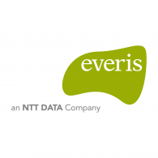EVERIS, now part of NTT DATA Morocco, is led by Mr. Fred Sabbah, the local managing director. The company is recognized as the 8th most valuable IT services consulting firm in Morocco, with over 24,500 employees worldwide. Located in Tétouan, EVERIS has been operating in the North region since 2016. With 3,500 professionals joining the company, it became the largest multinational in the TTAH region, employing over 1,200 people.

EVERIS focuses on creating qualified and stable jobs, with nearly 100% of contracts on permanent basis across all markets. In the last two years (2016-2018), the company has grown significantly, employing 3,500 professionals and expanding to over 24,500 employees worldwide.

NTT DATA Morocco works on various projects in software development, third-party application maintenance, and specific testing for major clients in Spain, Belgium, and the Netherlands, using cutting-edge technologies and multi-language support on leading technologies in various sectors, such as banking, insurance, telecommunications, industry, and public administration.

The company plans to double its workforce this fiscal year, with the main challenge being finding experienced candidates. NTT DATA Morocco opened a high-performance center in Casablanca in 2019 to strengthen its presence in Morocco.

In FY 2019 (March 31, 2018 - March 31, 2019), NTT DATA realized a revenue of 1,430 million euros, up 22% compared to the previous year. EBITDA reached 109 million euros.

These positive results reflect NTT DATA's commitment to talent and innovation as drivers of economic growth. The company's strategy focuses on developing new products and implementing digital transformation projects for its clients. This approach leverages the company's expertise in various sectors and its ability to form partnerships with the innovation ecosystem to anticipate client needs for disruptive technologies such as AI, blockchain, and more.

Projects in digital transformation represent 35% of the company's global revenue, positioning NTT DATA as the leader in applying exponential technologies like AI, blockchain, and more. In FY 2019, the Spanish market was the most profitable, with a growth of 21% and revenue exceeding 750 million euros. NTT DATA has over 12,500 professionals in Spain.

The EMEA market's revenue exceeded 1.05 billion euros, a 23% increase compared to the previous year, strengthening NTT DATA's presence in Europe and expanding its digital transformation projects for public and private sector organizations. The Spanish market accounted for more than 25% of total revenue.

**Services and production**

* Application services
* Automation
* BPO & Digital operations
* Business and technology consulting
* Cloud and IT infrastructure
* Cybersecurity
* Data and intelligence
* Digital work environment
* Emerging technologies
* Innovation
* Products

### Organization chart

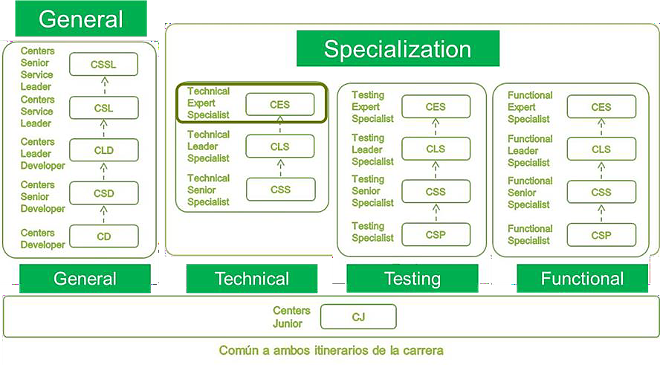

**Figure 3.** *NTT DATA -Hierarchy*

The following figure shows the organization of the NTT DATA teams.

Having presented the host environment, the company and its organization, I will now present the subject, the problem, the project management, the planning and the proposed solution.

## Presentation of the Project

### The scope of the project

Managing internships within an organization can be a complex and time-consuming task. The traditional manual methods of tracking, coordinating, and evaluating internships often lead to inefficiencies, miscommunication, and a lack of centralized information. This can result in difficulties in matching interns with suitable projects, monitoring their progress, and providing a meaningful learning experience. To overcome these challenges, a more efficient and automated system was required.

My task was the development of an Internship Management System web application. This application aimed to provide a centralized platform that would streamline the entire internship process, from application and selection, monitoring, and evaluation. The system would enable seamless communication between interns, supervisors, and the internship management team, facilitating efficient coordination and enhancing the overall internship experience.

### Methodology of work

When it comes to the method followed to achieve the project, The team adopted the organizational spirit of Scrum because the "Internships management" specifications can change at any time, and also to align with current practices at NTT DATA. And to ensure that the quality of the result was as close as possible to what was required.

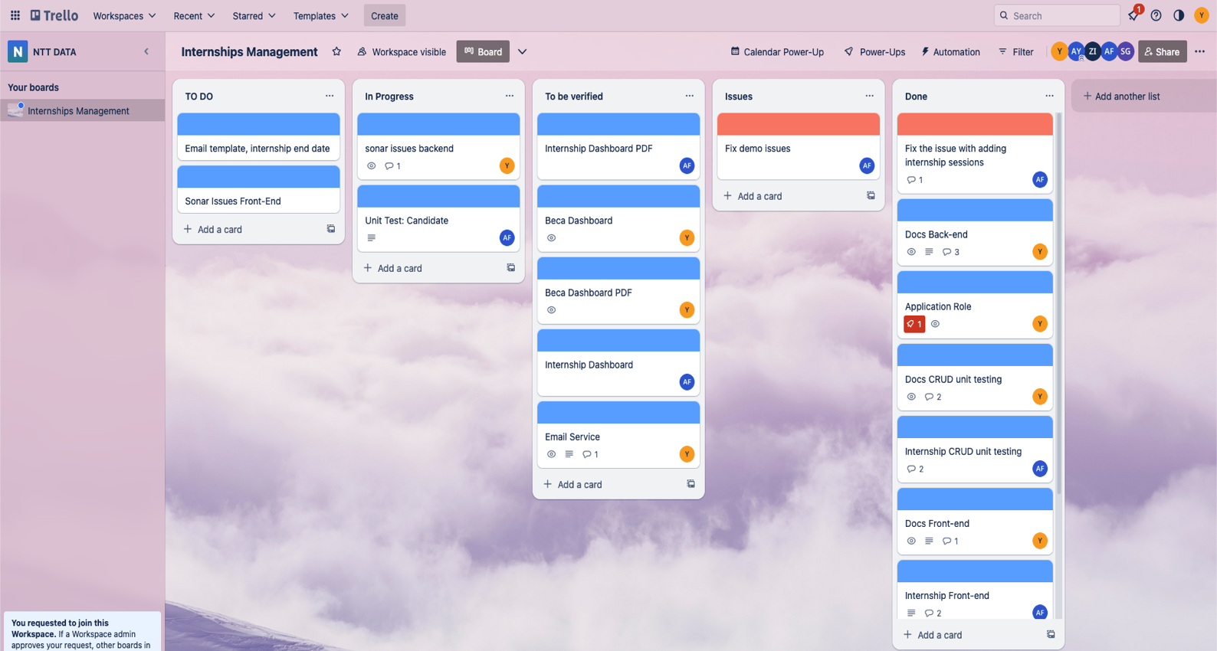

**Figure 4.** *Team-members-Tasks-Trello-Page*

We used the app called Trello, this application is suitable for coordinating our team work, and within it, my project supervisor created a workflow emulating that of Kanban, where we have tasks created and assigned to the designated team member, and each task can be picked up and set to in progress. Every task’s life cycle is as follows:

the possible states of each task are:

* **TO DO**

for tasks newly created and un-assigned to any member

* **In Progress**

for tasks being worked on

* **To be verified**

test phase of a task

* **Issues**

tasks that have a bug and should be fixed

* **Done**

for tasks that are verified and working as the requirements

### Timeline of the project

To ensure effective project management and timely completion of deliverables, a well-structured timeline was established for the Internship Management System web application project. This timeline provided a comprehensive overview of the project's key milestones and activities, serving as a roadmap for the development process.

the bellow figure shows a simplified version of the time line projected for the project, the main portion of the project life cycle is dedicated toward the iterative process of developing, testing and enhancing.

|  |  |  |  |
| --- | --- | --- | --- |
| Activity | Duration | Start Date | End Date |
| Training / Integration | 2 Weeks | 08/02/2023 | 28/02/2023 |
| Specifications | 3 Days | 01/03/2023 | 04/03/2023 |
| Design | 1 Day | 05/03/2023 | 06/03/2023 |
| Programming | 3 Months | 06/03/2023 | 10/05/2023 |
| Testing | 1 Month | 15/04/2023 | 15/05/2023 |

**Figure 5.** Simplified*Project timeline*

The actual time table went as follows:

**Figure 6.** *Actual project timeline*

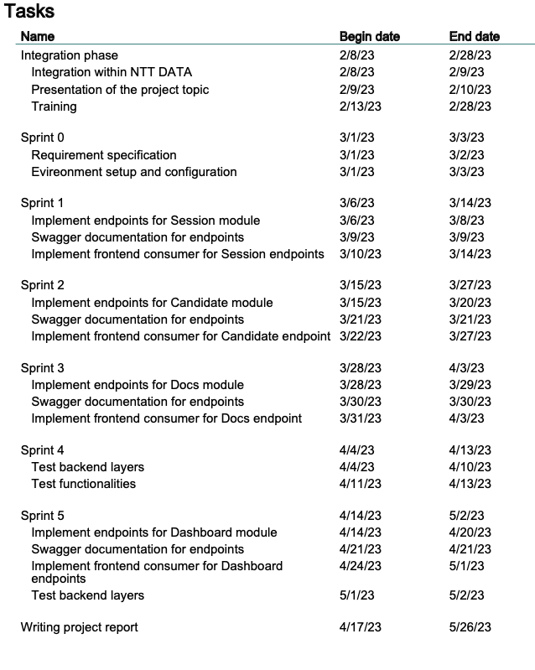

The following Gantt diagram shows the project timeline, with the main portion of the project life cycle dedicated to the iterative process of developing, testing and enhancing,

**Figure 8.** *Gantt diagram*

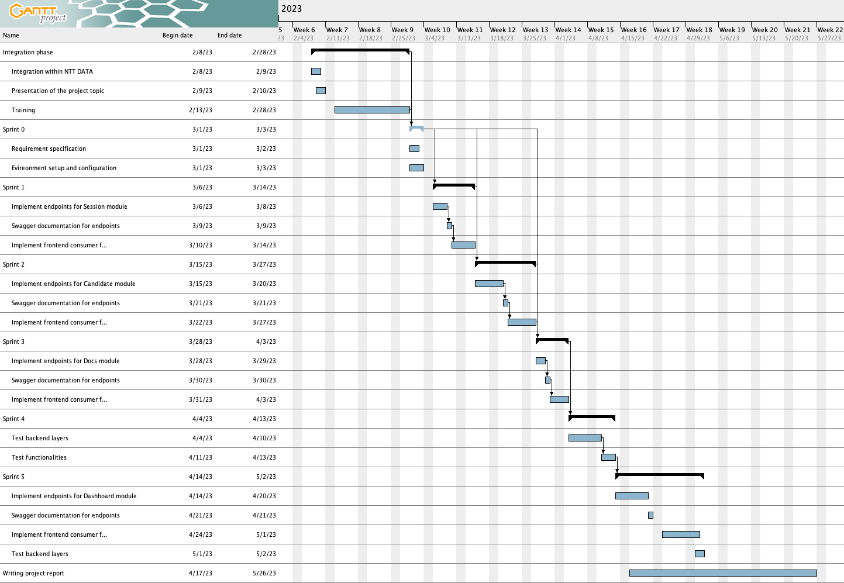

## Conclusion

This chapter sets out the context of the project. We introduced NTT DATA, the host organization, and its activities. We also defined the problem and presented the solution NTT DATA proposed to solve it. We then presented the schedule and life cycles used to complete the project.

Chapter

**2**

# Specification of requirements

This chapter presents the requirements of the project, the needs that it must fulfill.

Each software in its inception must define its own requirements, and the project must be able to fulfill them.

When it comes to functional needs the software as every other software needs to be maintainable, scalable, and efficient.

## Concepts and definition

the study of the requirements of a project constitutes an integral step of the life cycle of any project, since it helps us formalize in details what was sketched in the previous phases, and it paints a clearer idea about what has to be realized in terms of actions, actors and tasks.

## Specification of requirements

Before starting the requirements analysis, it's important to understand certain concepts so that we can specify and collect all the necessary business aspects.

These include:

**Session**: Sessions refer to the periods during which internship applications can be received. They are also linked to the availability of candidates, who are generally students pursuing their studies.

**Candidate**: Candidates are mainly students, but this is not an absolute necessity. Other people can benefit from internships at NTT DATA, such as graduates or, in some cases, company employees who are studying at a school or university. They must, however, have knowledge of the internship field and adequate insurance coverage;

**Internship**: The internship, as it is known, is a period during which the candidate is hired by the company to carry out tasks, familiarize himself/herself with the technologies used or attend meetings.

It is also necessary to be familiar with other types of resources, such as the documents used in the process (national identity card, insurance, agreement, certificate, etc.).

### Actors in the system

Our solution will be a management application, so we'll need actors to initialize and monitor it. Since the application is online, we'll need accounts to identify each type of user.

Users fall into two categories: Internship managers and system administrators.

- **Internship manager:** this may be a manager within the company, such as a manager, a supervisor in charge of interns, a member of the human resources department, as well as members of general management for strategic and business reasons.

- **Administrator:** this is the person or persons who have the right to control other users and carry out all actions that other users can perform.

The application is designed to be open to the addition of other users in the future. For example, if we integrate the management of other resources such as recruitment or certificates into the same application, we will be able to extend the functionality to include these types of resources.

### Functional requirements

Each of these main functions represents the management of one or more types of resource. In the following steps, we will detail each functionality (i.e. the possible operations on each resource). The resources we have identified by analyzing the existing process are: session, candidate, internship, documents, users, dashboard/statistics.

These resource types are grouped together in the application in the form of modules, this grouping being carried out by taking into account the links between these resources.

- **Session module:** resources linked to sessions

- **Candidate module:** resources linked to candidates

- **Internship module:** resources linked to internships and documents

- **User module:** accounts and user management

- **Dashboard module:** dashboard-related resources

For each module, we will examine all possible actions, enabling us to explain each use case in detail. We'll look at the different scenarios, the users involved, and the exceptions and alternatives to be considered. This approach will enable us to gain an in-depth understanding of the functionalities offered by each module, and to present them clearly and comprehensively.

### Session module

It has already been mentioned that sessions represent the periods during which candidates and placements are assigned to them. This module plays a central role around which the other modules are aligned.

Once the user accesses the session module interface, he or she will be able to consult a list of all available sessions. This list includes the following information: session name, and session start date. The presentation of the list offers functionalities such as sorting according to the different columns, the possibility of filtering sessions according to certain criteria, as well as a search function to quickly find specific sessions.

|  |  |
| --- | --- |
| Use Case | Add session |
| Description | Create a new session of internships |
| Actors | * Internship manager * Admin |
| Start Event | Visiting the session page |
| Basic Scenario | * the user visits the session page * the user opens the modal to add a new session * the user enters the name and the start date of the session * the system verifies the data |
| Alternative  Scenario | * If a current session already exists, it will be defined as the previous session before creating the new one. * If a previous session exists, it will be defined as closed. |
| Error Scenario | If the session name already exists, the addition will fail and the user will have to change the name to follow the normal scenario. |
| Pre-Conditions | User un-authenticated |
| Post-Conditions | A new session has been created as the current session |

### Candidate module

Once the sessions have been created, we will start receiving applications for internships. Before deciding whether or not to accept these applications, and in order to obtain initial information on the person making the request, it is necessary to store data on these applicants. The purpose of this module is to facilitate this data collection and to await the final decision of the company and the persons concerned.

|  |  |
| --- | --- |
| Use Case | Add candidate |
| Description | Create a new candidate |
| Actors | * Internship manager * Admin |
| Start Event | Visiting the candidate page |
| Basic Scenario | * The user accesses the candidate module pane. * Opens the add candidate form. * Fill in candidate details such as name, e-mail, city, level, etc. * Adds the candidate's CV. * Performs registration. * The CV document will be uploaded. * The candidate is added. |
| Alternative  Scenario | * If the candidate's city/school does not exist in the list of cities/schools, it must be added using a pop-up window. |
| Error Scenario | If the candidate's e-mail already exists, the addition will fail and the user will have to change the e-mail to follow the nominal scenario. |
| Pre-Conditions | User un-authenticated |
| Post-Conditions | Candidate has been created in the current session |

Acceptance/refusal functionalities:

The purpose of this function is to manage the status of candidates in the selection process for internships. Three types of status are possible for a candidate:

- **Empty:** this status corresponds to the candidate's initial addition to the system, before a decision is made on his/her application.

- **Accepted:** when the candidate is accepted for the internship, his/her status is set to "Accepted". This means that the applicant has been selected and can move on from being an applicant to being a trainee.

- **Rejected:** if the candidate is not selected for the internship, his/her status is set to "Rejected". This means that the applicant has been rejected and will not be able to continue the process.

### Internship module

At this point, the candidate has become an intern, and it is necessary to manage internship-related data, such as supervisor contact details. To meet these needs, we have created the internship module. This module makes it possible to manage all information relating to the internship. In addition, the module also integrates the management of documents related to the internship, as they form an important part of the internship resources.

|  |  |
| --- | --- |
| Use Case | Add internship |
| Description | Create a new internship for the accepted candidate |
| Actors | * Internship manager * Admin |
| Start Event | Visiting the Internship page |
| Basic Scenario | * The user accesses the Internship module. * Opens the add internship form. * Select the intern from the list of accepted candidates. * Fills in internship details such as start and end dates, subject and type of internship. * Fills in the supervisor's contact details, such as name, telephone number and e-mail address. * Adds internship documents (CIN, insurance, internship agreement). * Check-in. * Upload documents. * The internship is added. |
| Alternative  Scenario | * If no intern has been accepted and does not have an internship, it must first be created and/or accepted. |
| Error Scenario | The form will check that the dates (start and end) are in the right order, otherwise an error will be signaled. To follow the nominal scenario,  the user must check them. |
| Pre-Conditions | * The user must be authenticated. * A candidate must be added and accepted. * The candidate must not have an internship in this session. |
| Post-Conditions | A new internship must be created for the intern in the current session, with an "in progress" status. |

**Update Internship functionality:**

|  |  |
| --- | --- |
| Use Case | Update internship |
| Description | Makes changes to an internship, including internship data, supervisor data, documents used when adding, or changes the internship status. |
| Actors | * Internship manager * Admin |
| Start Event | Visiting the internship page |
| Basic Scenario | * The user accesses the Internship module. * Open the modification form for the internship specified in the list. * **Scenario 1:** * Modify internship or supervisor data, such as start and end date, subject, internship type, name, telephone and e-mail, as well as documents. * **Scenario 2:** * Add the internship report, changing the status of the internship to "Completed". * **Scenario 3:** * Add a grade to evaluate the report and the intern's work at the company, changing the internship status to "Rated". * The internship is saved. |
| Alternative  Scenario | If the end date of the internship has been reached and no report has been submitted, an e-mail is sent to the intern to remind him/her to submit it. |
| Error Scenario | In the case of scenario 2, a report is compulsory, otherwise adding notes will be blocked. |
| Pre-Conditions | User un-authenticated |
| Post-Conditions | * Internship must be created. * Editing the internship can have three different results: * Modify course data and documents; * Change course status to "Completed"; * Change course status to "Evaluated". |

## Specification of non-functional requirements

After having determined the functional needs, we present below all the constraints to be respected to guarantee the performance of the system while respecting the requirements of the user.

* Performance: The application must ensure a minimum response time while meeting the needs of the manipulator;
* Simplicity: Every user will be able to use this application in an easy and clear way;
* Ergonomics: Interfaces should be simple and user-friendly;
* Modularity: Have simple code that is easy to maintain and understand when needed;
* Maintainability: the project’s inner working should be maintainable and conform to industry standards;
* Security: Data and user security are paramount. The application must implement safeguards such as secure authentication and appropriate access controls to prevent any breach or misuse.

## Conclusion

This chapter addressed the various requirements the projects need to follow and fulfil, mainly from the administrator’s and the manager’s points of view, this chapter also defined some basic non-functional needs the project has, such as modularity, portability, and Maintainability.

Chapter

**3**

# Design

This chapter is dedicated to the conceptual aspect of this project. It then presents a preliminary design for moving on to modeling the system using a class diagram. This chapter also outlines a number of diagrams describing how the user interacts with the application.

## Introduction

In this chapter we present the various concepts developed for the project, in both manners: general and detailed.

## UML

The Unified Modeling Language is a standard visual modeling language used for:

- Modeling activities and similar processes.

- Analysis, design and implementation of software systems.

UML is a common language for software analysts, architects and developers, used to describe, specify, design and document existing or new processes, structure and behavior of software system artifacts.

The UML language can be applied to a variety of application domains (e.g., banking, finance, Internet, aerospace, healthcare, etc.). It can be used with many other tools (e.g., J2EE, .NET).

UML is a standard language model, not a software development process. The UML 1.4.2 specification explained this process:

- Provides guidance on the order of a team's activities,

- Specifies which artifacts are to be developed,

- Directs the tasks of individual developers and the team as a whole, and

- Suggests criteria for monitoring and measuring project products and activities.

### Diagrams

##### Class diagrams

Class diagrams are one of the most useful types of diagrams in the UML language, playing a central role in object-oriented design. They provide a graphical representation of the classes, associations, inheritances and dependencies that make up the system, clearly describing its static structure.

The following figure shows the overall class diagram for the project:

CHAPTER 3.

DESIGN

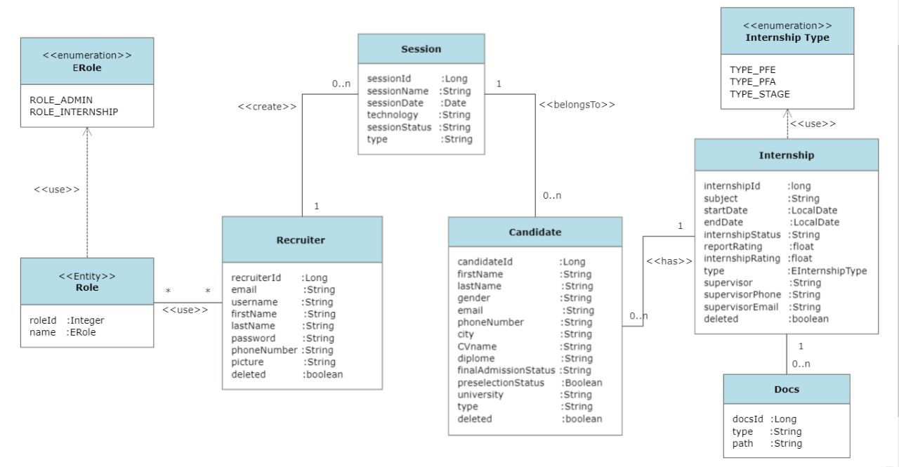

**Figure 9.** Class*Diagram*

##### Use case diagrams

Use case diagrams are an essential tool in software development that visually represent the functional requirements and interactions of a system. They provide a high-level overview of the system's behavior by capturing various use cases or scenarios. In this section, we will introduce five key use case diagrams that have been developed for the Internship Management System web application.

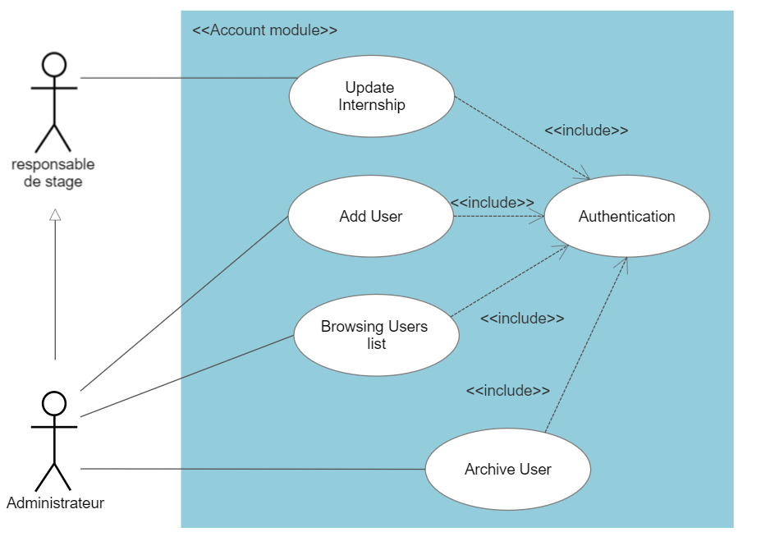

**Figure 10.** *Accounts management Use case diagram*

The first diagram, the Accounts and Users Use Case Diagram, outlines the use cases associated with managing user accounts and profiles. It encompasses actions like creating an account, updating user information, and managing user roles and permissions.

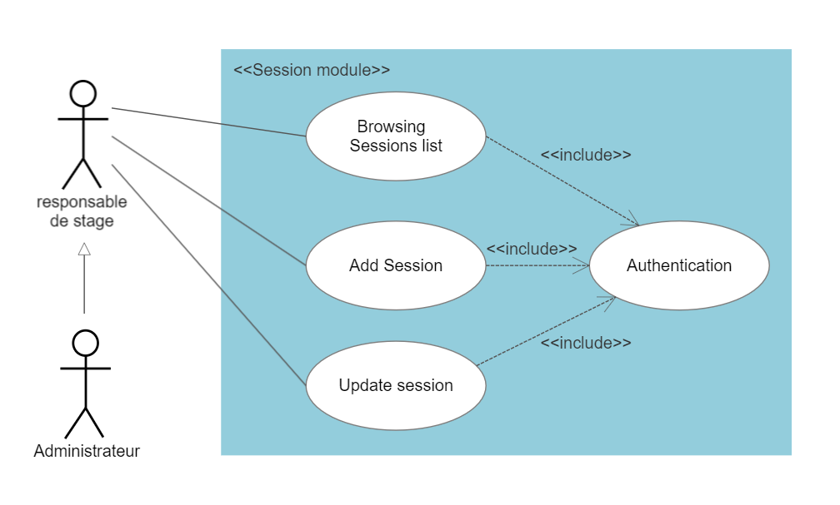

**Figure 11.** *Session Use case diagram*

The second diagram, the Session Use Case Diagram, focuses on the functionalities related to user sessions, such as login, logout, and session management. This diagram illustrates the interactions between the system and users during their session.

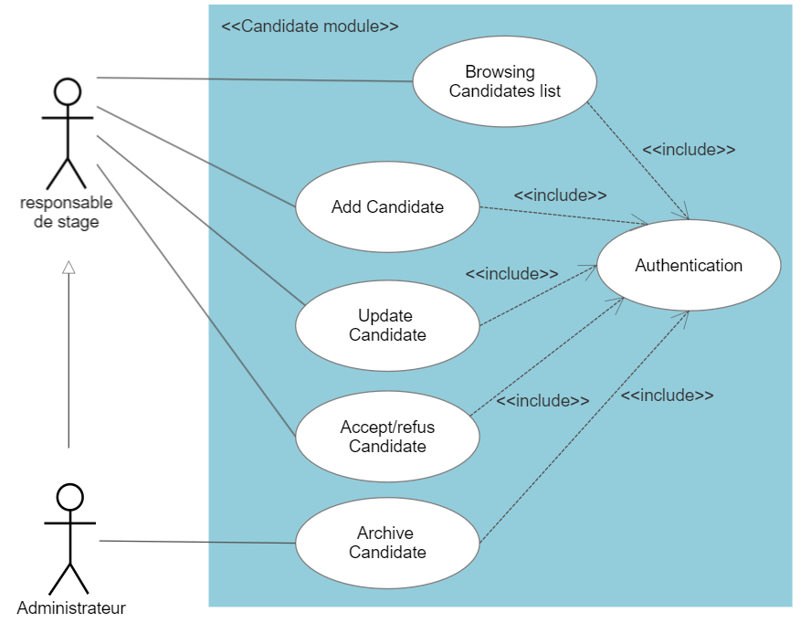**Figure 12.** *Candidate Use case diagram*

The Candidate Use Case Diagram presents the functionalities related to managing internship candidates. This includes use cases such as candidate registration, profile creation, and application submission.

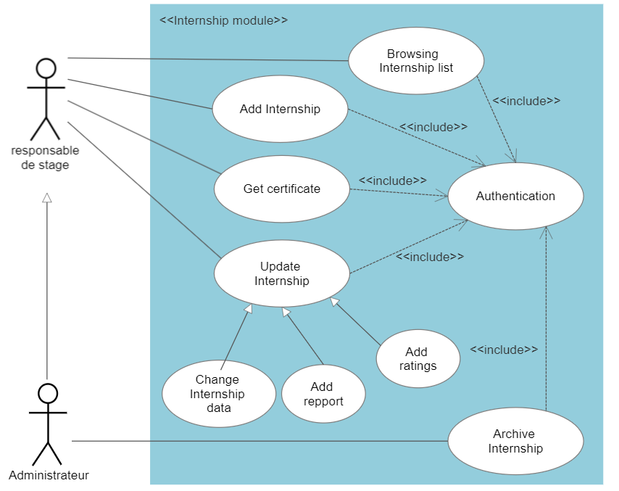

**Figure 13.** *Internship Use case diagram*

The Internship Use Case Diagram highlights the interactions and functionalities related to managing internships. It includes use cases like creating and updating an internship, reviewing applications, and evaluating candidate performance.

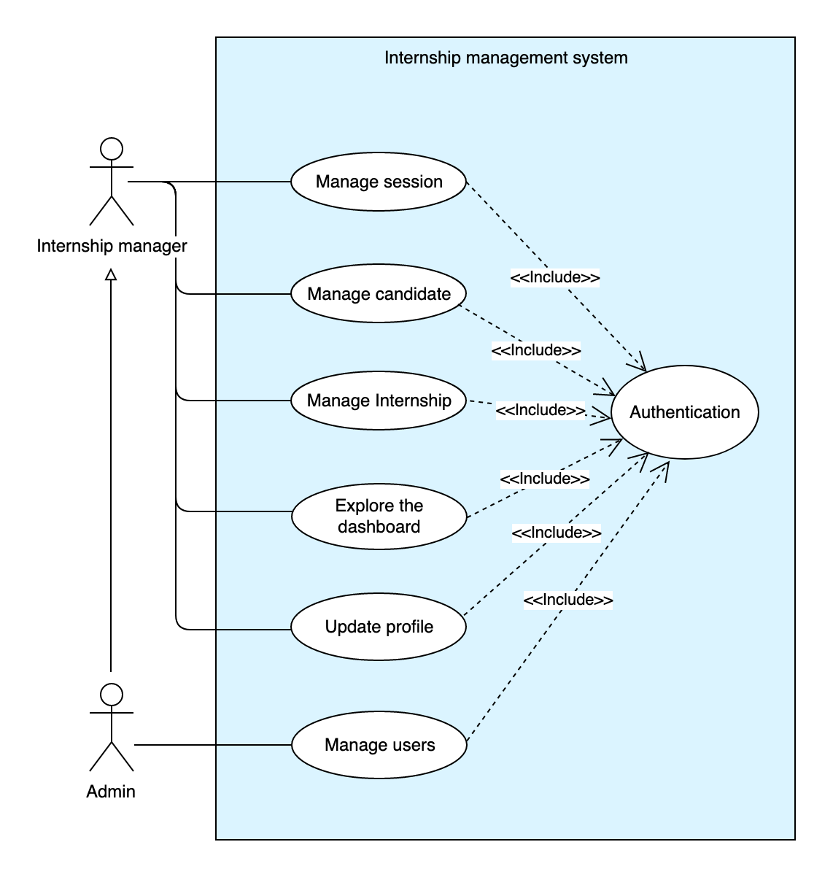

**Figure 14.** General *Use case diagram*

The general Use Case Diagram provides an overview of the system's global functionalities that are not specific to a particular module.

##### Sequence diagrams

A sequence diagram is a type of interaction diagram, as it describes how and in what order several objects work together. These diagrams are used by both software developers and business managers to analyze the requirements of a new system or document an existing process. Sequence diagrams are sometimes referred to as event diagrams or event scenarios.

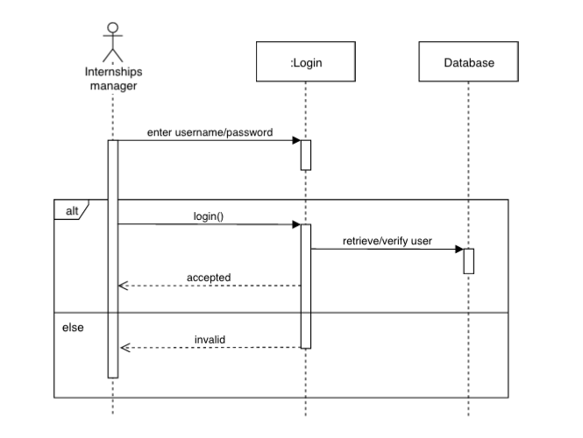**Figure 15.** *Authentication sequence diagram*

## . Conclusion

In conclusion, this chapter provided an overview of the use case diagrams for the Internship Management System web application. The diagrams, including Session, Accounts and Users, Candidate, Internship, and General, visually depicted the system's functionalities and interactions. These diagrams serve as a valuable tool for understanding and communicating the system's requirements and capabilities.

CHAPTER 3.

DESIGN

Chapter

**4**

# Programming

This chapter will delve into the implementation process and tools used to achieve that, as well as the results of the implementation, and the various tests that were performed.

First, we will see the tooling utilized to implement the software,

In the next part we will showcase the results of the implementation, both the front-end and the backend, and explain some example functionalities.

And lastly, we will show and explain various tests done to verify the soundness and correctness of the software.

## Introduction

Every software life-cycle passes from the implementation phase, and this phase is one of the most important phases of the project’s life, to do it, the Development team uses various technologies, and tools to bring the project to life, this chapter will go through some of these tools.

## Development environment

In this Section we will explore the various tools and technologies used during the implementation of the project, we can separate them into different categories, tooling, organization, technologies.

* Tooling: the various tools such as IDEs, text editors and other software that were used to directly implement the project;
* Organization: the tools that were used to coordinate and organize the team’s tasks and work;
* Technologies: the various Languages and APIs ... etc. that were used to implement certain features in the project;

### Tooling

Tooling software as stated above is the collection of application used to host the implementation process of the project.

* + - Visual Studio (VS) Code: a versatile code editor developed by Microsoft (MSFT), extended by the Angular extensions and intellisence it provides a powerful coding and debugging context;

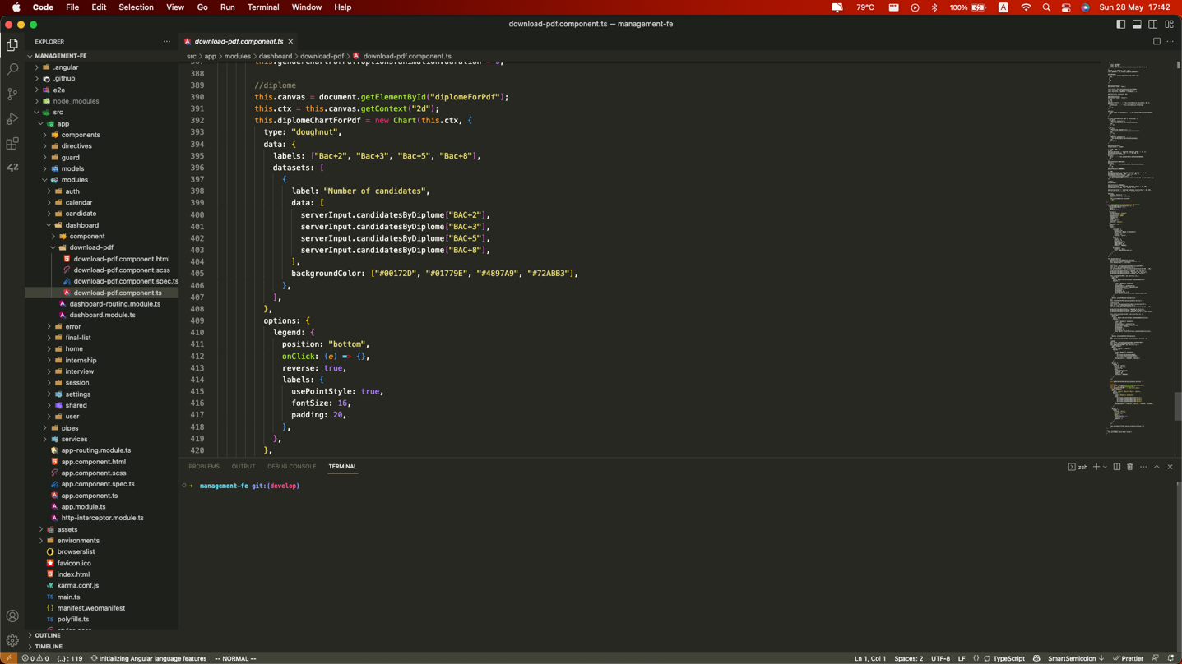

**Figure 16.** *Screenshot of Visual studio code*

* IntelliJ IDEA: is a popular Java integrated development environment (IDE) developed by JetBrains. It offers a user-friendly interface and a wide range of features for streamlined Java development. With intelligent code completion, debugging tools, and support for various frameworks, IntelliJ IDEA enhances productivity and code quality. It also provides support for web development and integrates with version control systems. Overall, it is a highly regarded IDE for Java programmers.

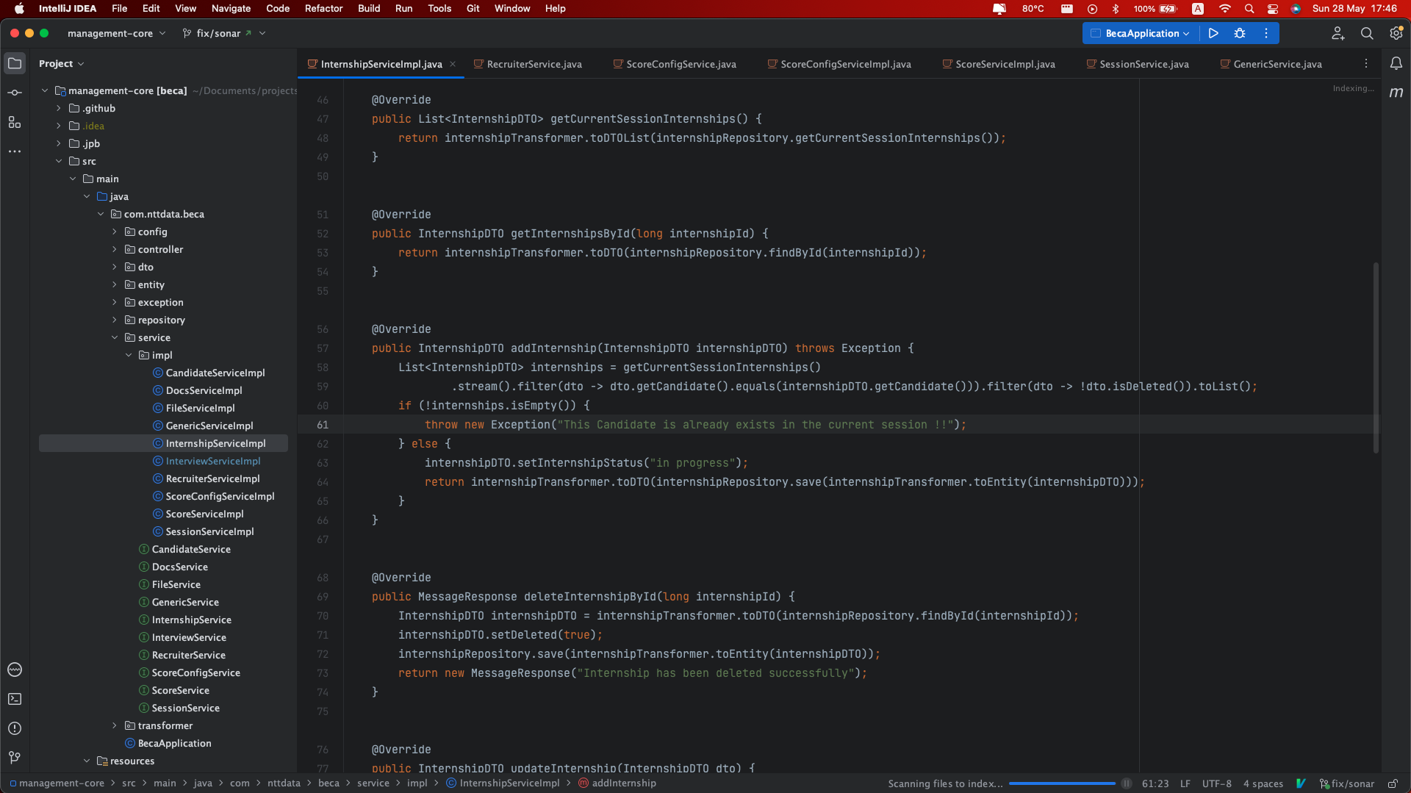

**Figure 17.** *Screenshot of IntelliJ IDEA Editor*

### Organization

For organization we used some unconventional for team coordination and some conventional software to coordinate the implementation process. From these we mention:

* + - Microsoft Teams: is a collaborative communication platform that integrates chat, video meetings, file storage, and app integration. It allows individuals and teams to connect, collaborate, and stay organized in one workspace. With features like real-time messaging, audio/video calling, and seamless integration with other Microsoft 365 applications, Teams provides a secure and flexible solution for effective team collaboration and communication.

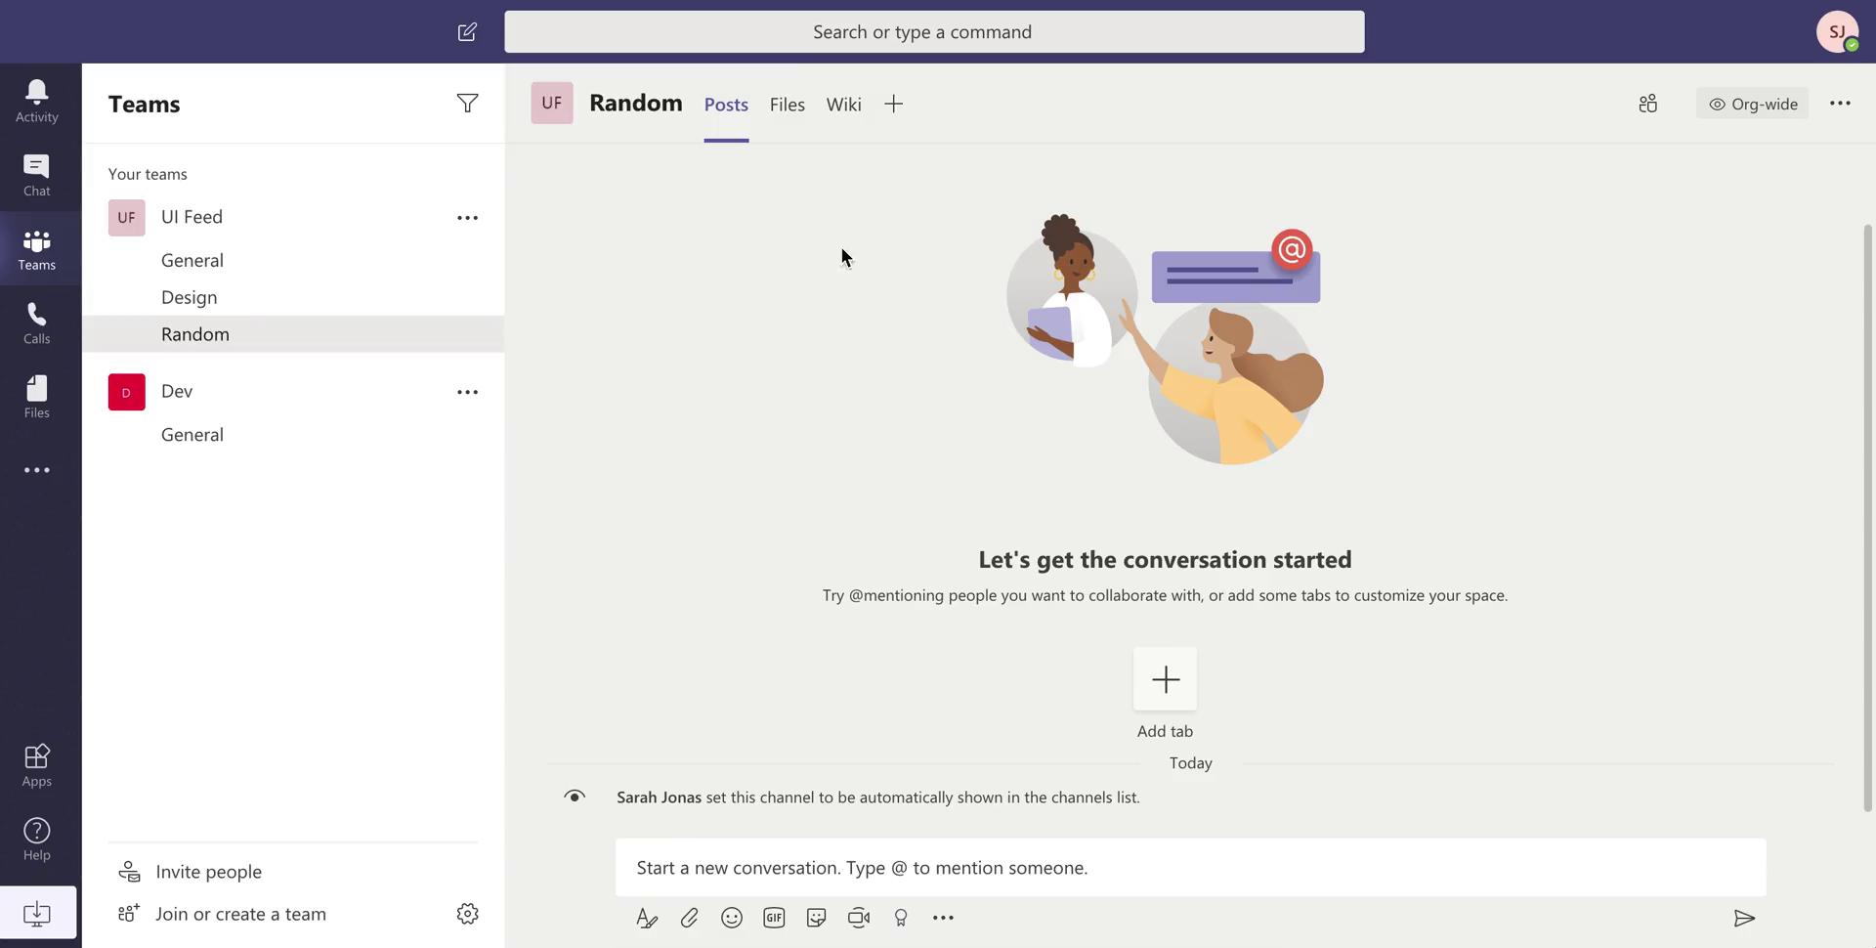

**Figure 18.** *Screenshot of MS Teams*

* + - 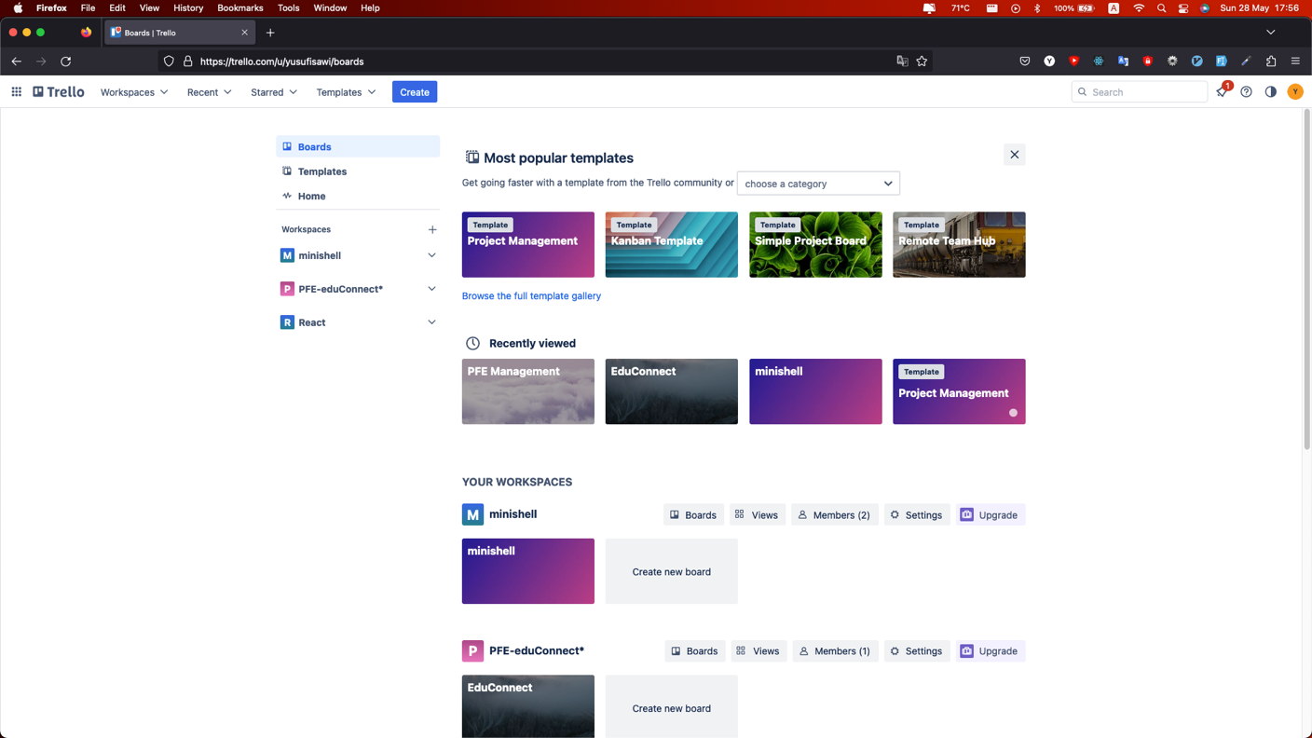Trello: is a web-based project management tool that helps teams organize and track tasks using boards, lists, and cards. With a simple interface and features like drag-and-drop functionality, due dates, and attachments, Trello facilitates task management and collaboration in a visually appealing way. It is widely used for efficient project organization and tracking.

**Figure 19.** *Screenshot of Trello App*

* + - 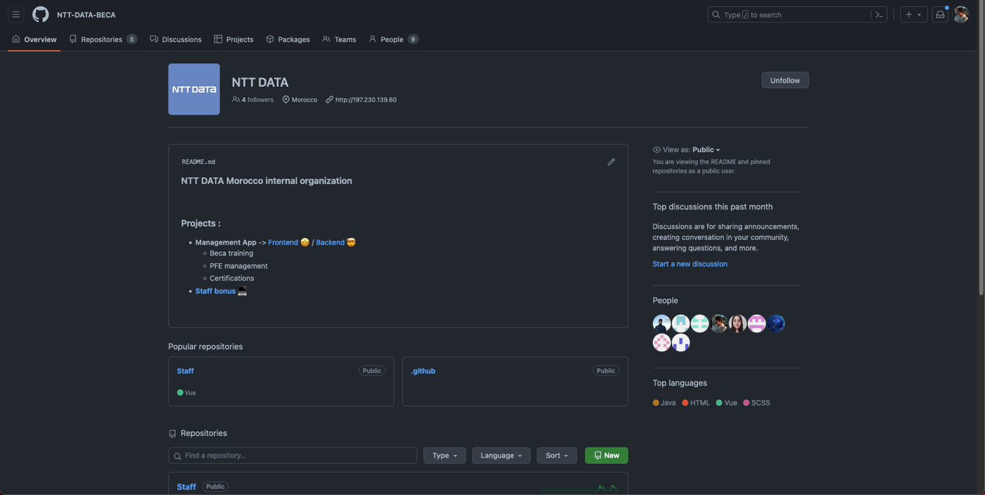GitHub: GitHub, Inc. is a provider of Internet hosting for software development and version control using Git. It offers the distributed version control and source code management functionality of Git, and we use it to coordinate coding, and deploy Tests as CI/CD process;

**Figure 20.** *Screenshot of GitHub website*

### Technologies

When it comes to technologies our team used various technologies to achieve its goal, these tools can be divided into different categories, such as: programming languages, API and Frameworks.

* + - Programming Languages: we used **Java** and Typescript as main programming languages, and **MySQL** as the relational database system.
      * **Java** is a versatile and widely-used programming language known for its platform independence. It is object-oriented and offers a robust environment for building applications. With its "write once, run anywhere" capability, Java code can be executed on any platform with a Java Virtual Machine (JVM). Java's extensive standard library, focus on security, and broad community support contribute to its popularity in diverse application development.
      * **Typesc**ript, we used it as an alternative to JavaScript, since we wanted to benefit from Typescript’s compiler to catch as much preventable bugs as possible, and syntax wise it is similar to Java which makes the switch seamless and not a big deal, we used it to implement the host website as well as the interop layer.
      * **MySQL** is a popular open-source relational database management system known for its reliability and performance. It offers advanced features, high availability, and robust security. MySQL is platform-independent, widely used in web applications, and integrates well with various programming languages.
    - **SonarQube**: is an open-source code analysis tool that helps developers improve code quality and detect issues. It supports multiple programming languages and provides actionable insights for bug detection, vulnerability identification, and coding standard compliance. With seamless integration into development workflows, SonarQube enables continuous code quality management and promotes software reliability.
    - **Frameworks**:

**Spring Framework** is an open-source Java platform that provides comprehensive infrastructure support for developing robust Java applications very easily and very quickly. Spring Framework was originally written by Rod Johnson and first released under the Apache 2.0 license in June 2003.

**Figure 21.** *Spring logo*

**Advantages of using spring:**

No need for an EJB container product such as an application server, but the option of using only a robust servlet container such as Tomcat or a commercial product.

Spring is organized on a modular basis. You choose what you need and ignore the rest.

Spring boot

Spring Boot is a project or micro-framework designed, among other things, to facilitate the configuration of a Spring project and reduce the time required to start up a project. Most Spring Boot applications require very little Spring configuration.

**Its features:**

* Create stand-alone Spring applications.
* Integrate directly with Tomcat or Jetty (no need to deploy WAR files).
* Provide starter project object models (POMs) to simplify Maven configuration.
* Automatically configure Spring as much as possible without XML configuration.
* Provide production-ready features such as metrics, health checks and outsourced configuration.

**Figure 22.** *Spring boot logo*

**Spring security**

Spring Security is a lightweight security framework (Java/Java EE) that provides authentication and authorization support to secure Spring applications. It comes with implementations of popular security algorithms.

It provides comprehensive security services for Java EE-based enterprise software applications.

Two main areas of application security are "authentication" and "authorization" (or "access control"). These are the two main areas targeted by Spring Security.

**Figure 23.** *Spring security logo*

**Angular**

Developed by Google, Angular is an open-source client-side framework written in JavaScript. Angular is a complete rewrite of AngularJS, enabling the creation of web applications, and more specifically so-called "Single Page Applications": web applications accessible via a single web page, making the user experience smoother and avoiding page loads for each new action. The Framework is based on an MVC-type architecture, enabling the separation of data, visuals and actions for better management of responsibilities. This type of architecture has proved its worth, offering high maintainability and improved collaborative working.

**Figure 23.** *Angular logo*

**Development tools and environment**

Apache Maven (commonly known as Maven) is a tool for managing and automating the production of Java software projects in general and Java EE in particular. It is used to automate continuous integration during software development. Maven is managed by the Apache Software Foundation. The tool was previously a branch of the Jakarta Project organization.

**Its features include**

* Compilation and deployment of Java applications (JAR, WAR)
* Management of libraries required by the application
* Execution of unit tests
* Generation of project documentation (website, pdf, Latex)
* Integration into various IDEs (Eclipse, IntelliJ)

**Figure 24.** Apache*Maven logo*

**Nodejs and npm**

**Node.js**

Is an open-source JavaScript software platform designed for highly concurrent, event-driven network applications that need to scale.

It uses the V8 virtual machine, the libuv library for its event loop, and implements the CommonJS specification under MIT license.

Node.js native modules include http, which enables HTTP server development. This means that, when deploying websites and web applications developed with Node.js, you don't need to install and use web servers such as Nginx or Apache. In concrete terms, Node.js is a low-level environment for server-side JavaScript execution. Node.js is used in particular as a web server platform

**Npm**

A package manager is a dependency manager. npm allows you to install all the libraries, frameworks and tools required by a JavaScript project.

These dependency management tools: Maven for the back-end and Npm for the front-end were very useful for our project.

The following paragraph introduces the testing tools and frameworks that helped us to detect errors quickly.

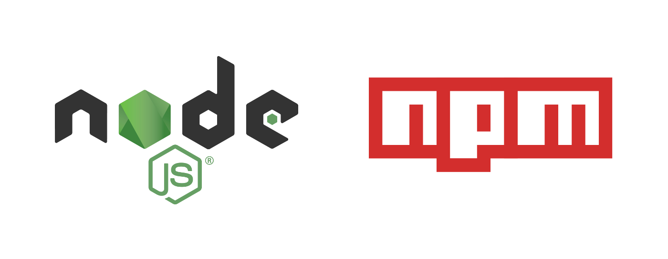**Figure 25.** *node + npm logo*

**Testing tools and frameworks**

**JUnit**

JUnit is a unit-testing framework for the Java programming language, created by Kent Beck and Erich Gamma. It is part of the xUnit family of frameworks. JUnit defines two types of test files:

Testcases are classes containing a number of test methods. A Testcase is generally used to test the correct operation of a class.

A Test Suite allows you to execute a number of Testcases that have already been defined.

It enables automated integration, based on assertions that compare the current result with the expected one, and the grouping of tests into a test suite and visualization of the result using tools.

**Figure 26.** *Junit 5 logo*

**Mockito**

Mockito is an open-source testing framework for Java published under the MIT license, often used in conjunction with Junit, which supports object emulation. During unit testing and to ensure test isolation, we mock or emulate the behavior of external dependencies and components, and we can define the return value of this object if it is invoked throughout the test.

The framework enables the creation of dual test objects (dummy objects) in automated unit tests for the purposes of test-driven development (TDD) or behavior-driven development (BDD).

As a mocking framework, Mockito enables you to:

- Mock invoked methods: by determining call parameters and their return values,

- Know the order in which these methods are invoked,

- Know the number of times these methods are invoked.



**Figure 26.** *Mockito logo*

## Application

### Authentication

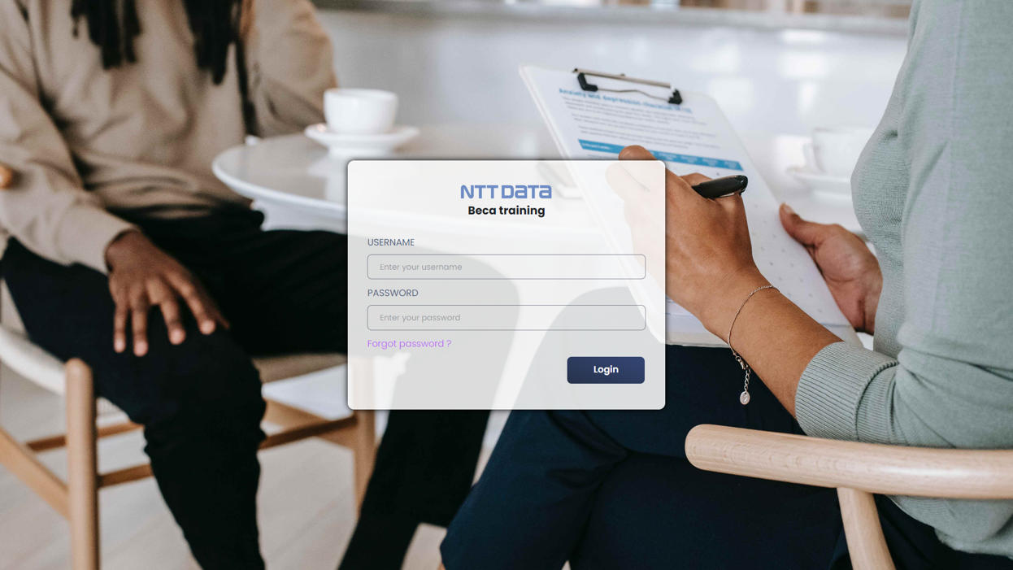

**Figure 26.** *Login page*

The login screen provides a secure way for users to access their accounts. It offers a user-friendly interface for entering login credentials. The design prioritizes simplicity and ease of use. Security measures protect user data during authentication.

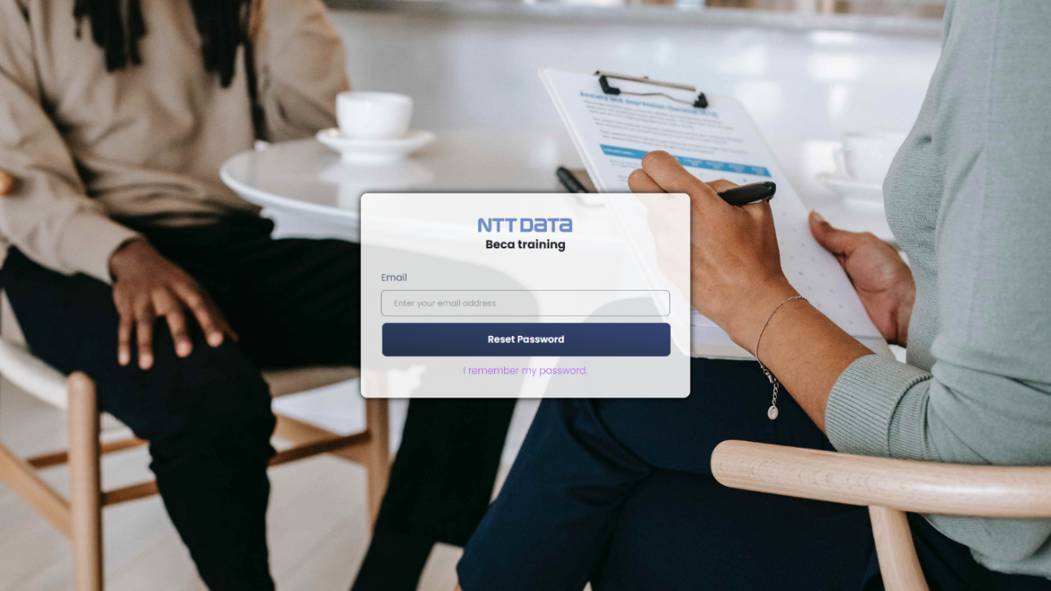

**Figure 27.** *Forgot password screen*

The reset password screen allows users to recover their account access by resetting their password. It provides a straightforward interface for users to enter their email or username associated with their account. By following the necessary steps, users can reset their password and regain access to their account. The reset password screen emphasizes simplicity and clarity to ensure a smooth recovery process.

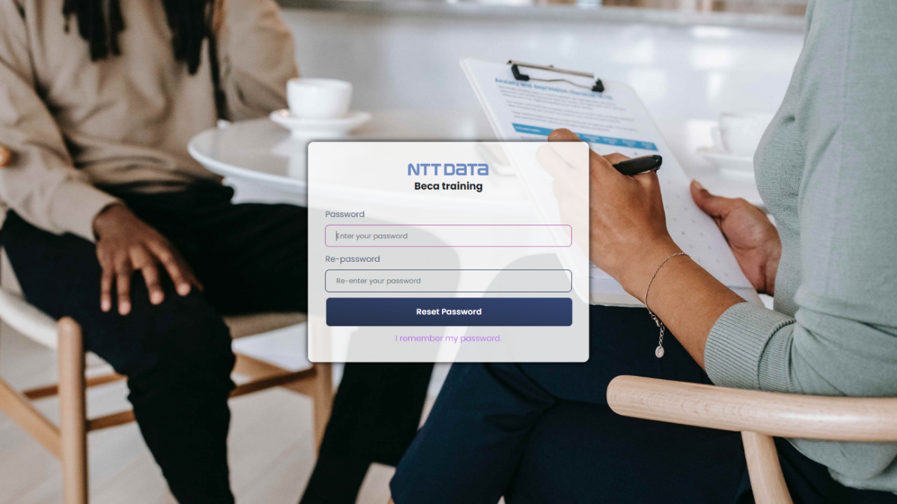

**Figure 28.** *Reset password screen*

### Dashboard

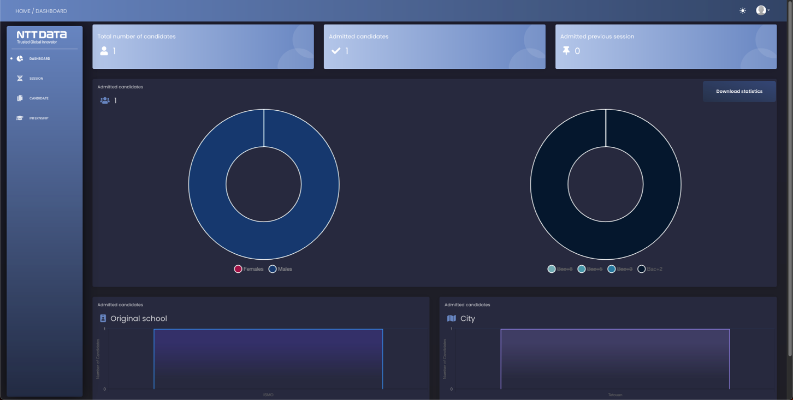

**Figure 29.** *Dashboard (first screen when logged in)*

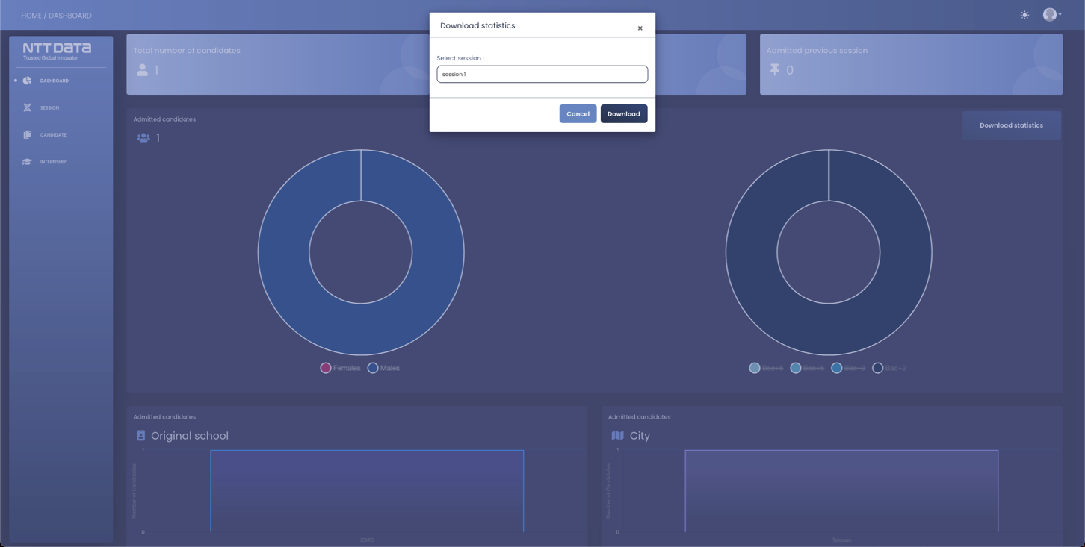The dashboard screen presents comprehensive statistics related to candidates and internships, offering valuable insights for analysis. It includes information on universities and cities, allowing users to identify trends and patterns in the candidate pool. The dashboard also provides statistics based on gender, enabling users to understand the gender distribution among candidates.

**Figure 30.** *Download Statistics modal*

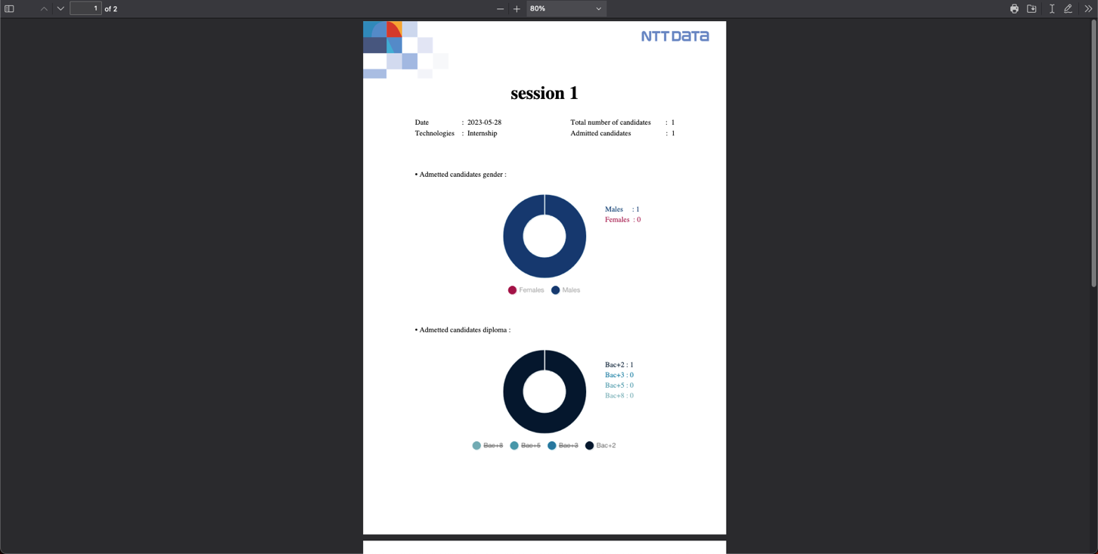Additionally, the dashboard offers a convenient feature where users can download a PDF document containing detailed statistics for the current session. This PDF provides a comprehensive overview of the statistical data, allowing users to further analyze and share the information as needed.

**Figure 31.** *Session**Statistics PDF template*

Overall, the dashboard screen serves as a powerful tool for users to access and interpret meaningful statistics related to candidates and internships, facilitating informed decision-making and strategic planning.

### Users space

The admin profile page is a dedicated section designed exclusively for administrators to manage account information and user roles within the application.

Administrators have the privilege to edit their account details, such as name, email, and contact information, directly from the admin profile page. This allows them to keep their information up to date and ensure accurate records.

Furthermore, the admin profile page grants exclusive access to add new users to the system and assign specific roles to them. Administrators can create accounts for new users, define their roles, and assign appropriate permissions based on their responsibilities. This control over user management helps maintain a secure and organized environment within the application.

By consolidating these administrative functions in one place, the admin profile page provides a streamlined and efficient experience for administrators to manage account information and user roles effectively.

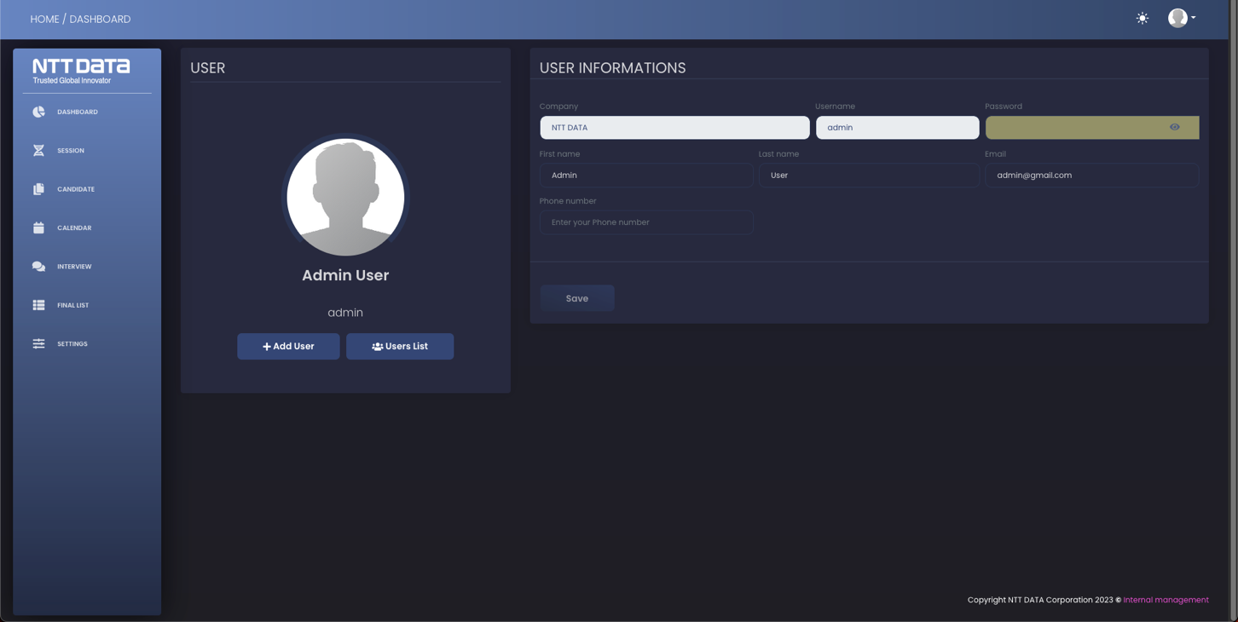

**Figure 32.** *Admin profile page*

### Session page

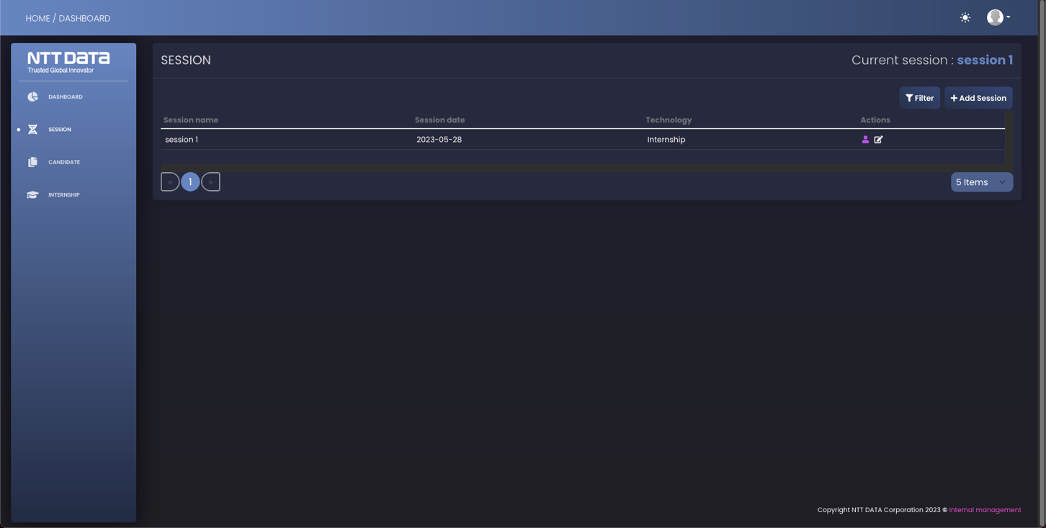 The session page is a dedicated space for the internship manager to oversee and manage internship sessions within the application.

**Figure 33.** *Session UI*

The internship manager has the ability to open a new internship session directly from the session page. This feature allows them to initiate a new session by specifying relevant details such as session duration, start and end dates, and any specific requirements or guidelines.

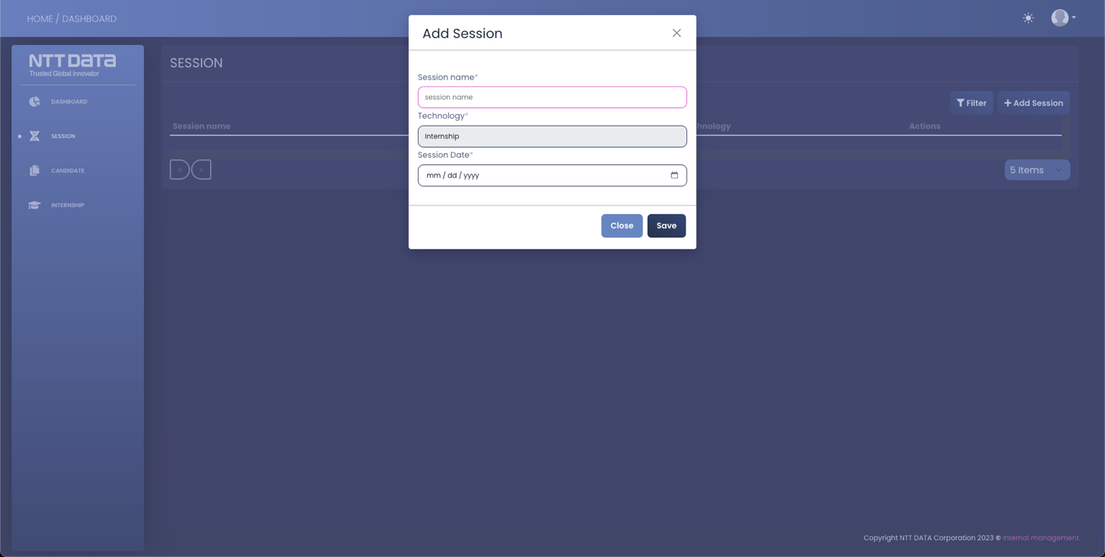

**Figure 34.** *Adding a new session modal form*

The session page provides a comprehensive view of all the internship sessions. The internship manager can easily access and navigate through the list of sessions. They can also apply filters to sort and refine the sessions based on specific criteria such as session dates, program types, or other relevant parameters. This filtering capability facilitates efficient session management and helps the internship manager quickly locate the desired information.

By centralizing these features on the session page, the internship manager can effectively create and monitor internship sessions, ensuring smooth operations and streamlined access to session details.

### Candidate page

The candidate page serves as a comprehensive platform for the internship manager to handle candidate management tasks efficiently.

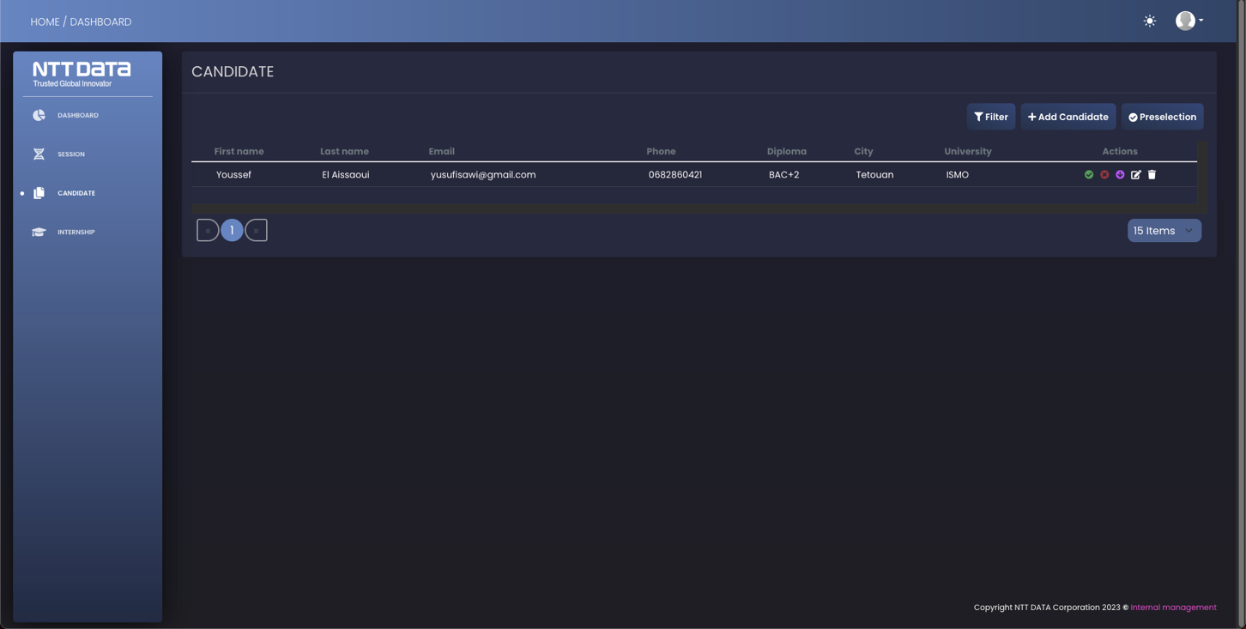

**Figure 34.** *Candidate page*

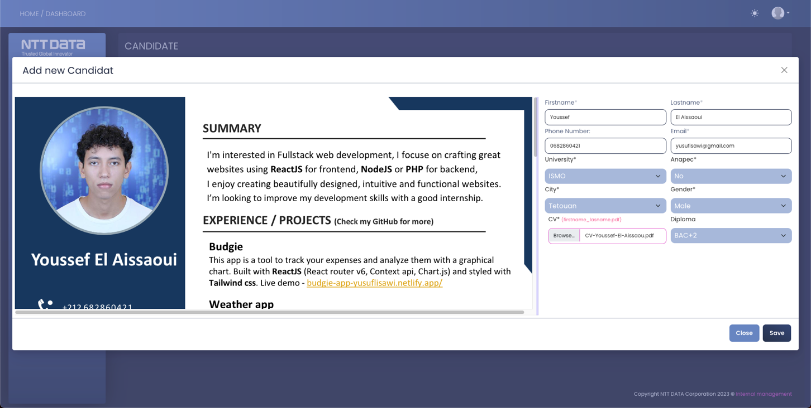

**Figure 35.** *Adding a candidate form (modal)*

On the candidate page, the internship manager has the ability to add new candidates by uploading their CV and entering relevant information such as the candidate's city, university, gender, and other necessary details. This feature simplifies the process of adding new candidates to the system and ensures their information is accurately recorded.

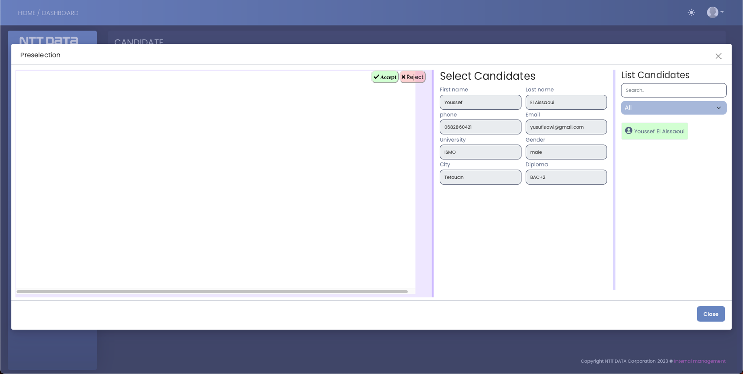

**Figure 36.** *Accepting/rejecting a candidate modal*

The candidate page also provides powerful filtering capabilities, allowing the internship manager to sort and refine the candidate list based on various criteria. This feature enables the manager to easily search for specific candidates based on attributes such as university, city, or skills.

Additionally, the internship manager can take action on candidate profiles directly from the candidate page. They can review the candidate's information and make decisions by accepting or rejecting them for the internship position. If a candidate is accepted, the manager can proceed to add them to the internship, completing the placement process.

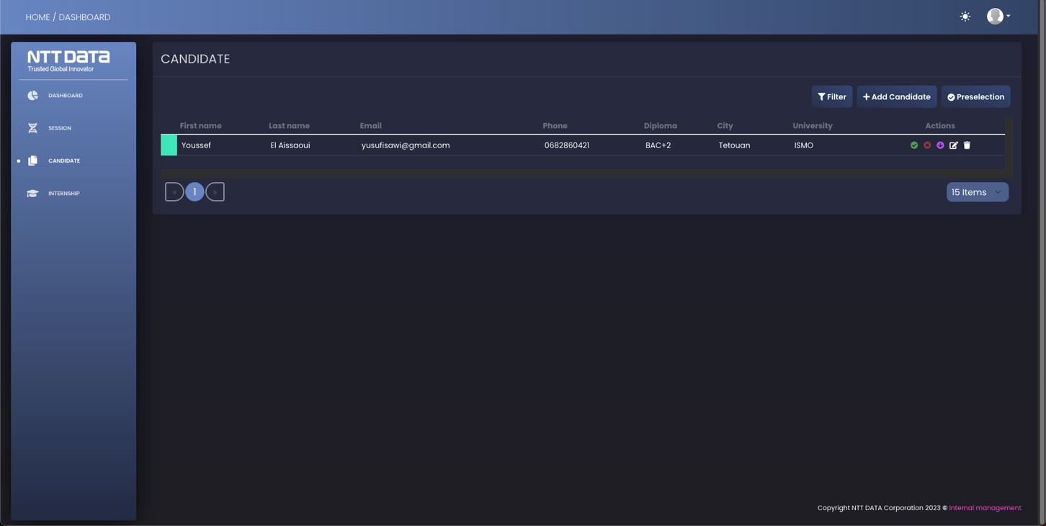

**Figure 37.** *Candidate accepted*

By incorporating these features into the candidate page, the internship manager gains control over candidate management, including adding new candidates, filtering the candidate list, and making informed decisions about their acceptance into the internship program.

### Internship page

The internship page provides a comprehensive platform for the internship manager to manage and oversee all aspects of the internships within the system.

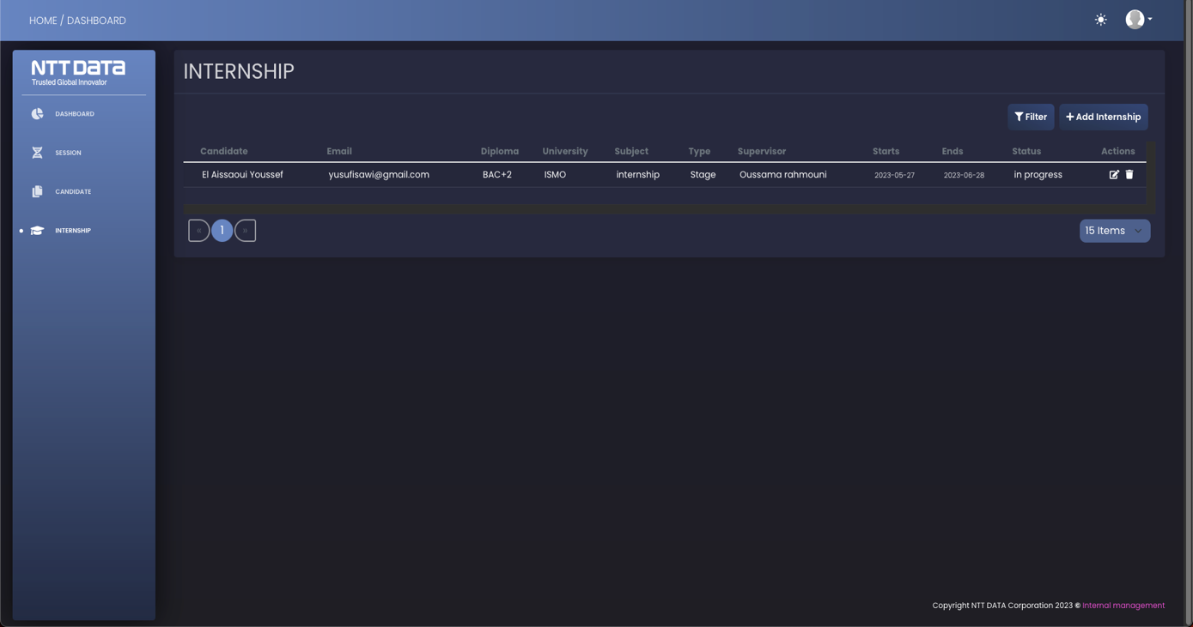

**Figure 38.** *Internship page*

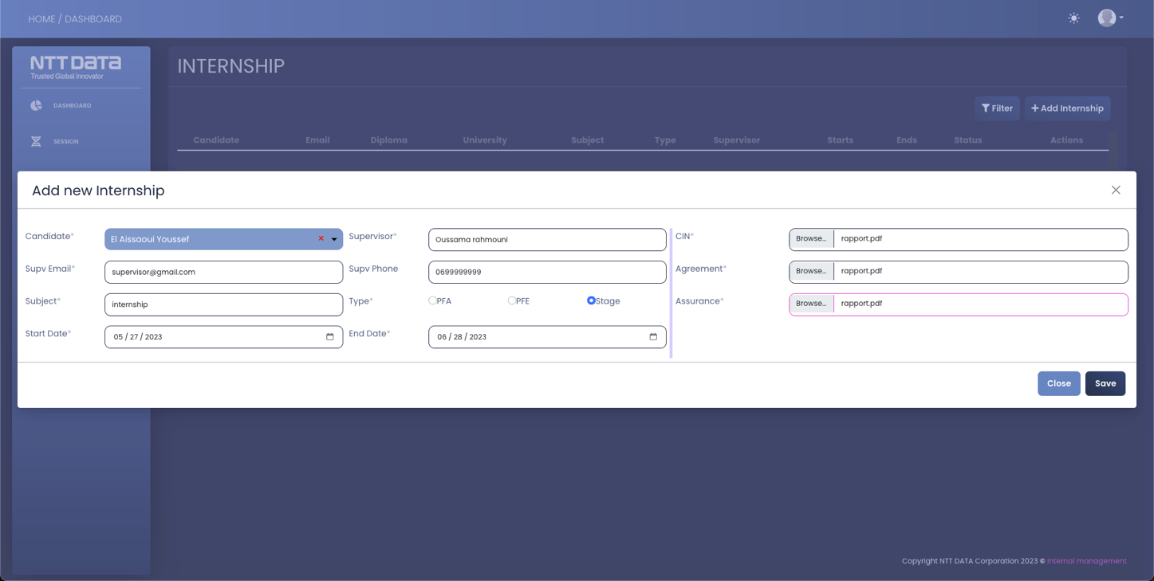From the internship page, the manager can add accepted candidates to their respective internship positions. They can input details such as the internship duration, type, and assign a supervisor to each intern. This allows for effective organization and tracking of internships.

**Figure 39.** *Adding a candidate to an internship modal*

Additionally, the internship page facilitates the uploading of necessary documents such as identity, assurance, and agreement forms. These documents ensure compliance and provide a record of important information related to the internship.

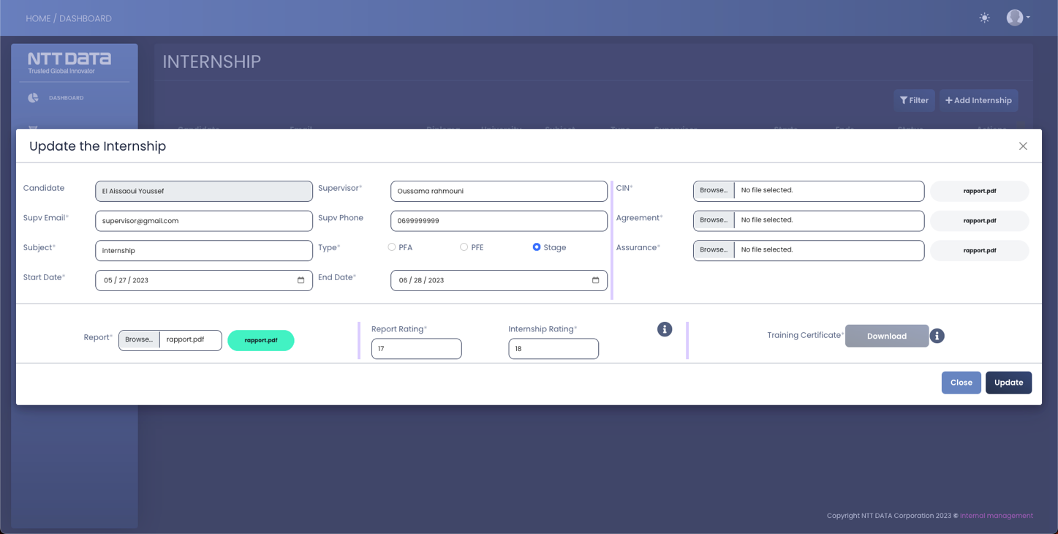The page also offers the functionality to view and filter internships based on various criteria, such as duration, type, or supervisor. This enables the manager to quickly access specific internship details and retrieve relevant information as needed.

**Figure 40.** *Updating the internship modal*

At the end of the internship, the intern can upload their internship report through the internship page. The manager can then evaluate the report and provide feedback. Furthermore, the manager can generate and download the intern's internship certification, acknowledging their successful completion of the internship program.

Through the features and capabilities of the internship page, the internship manager can effectively manage all aspects of internships, including adding candidates, assigning supervisors, uploading necessary documents, evaluating reports, and issuing internship certifications.

## Conclusion

In conclusion, this chapter has presented the key functionalities of the internship management web application. It offers a user-friendly login interface and a comprehensive dashboard for tracking candidate and internship statistics. The admin profile page ensures secure account management and role assignment. The session page facilitates easy creation and organization of internship sessions. The candidate page enables efficient candidate management, including filtering, acceptance/rejection, and document uploads. The internship page streamlines internship management, allowing for candidate assignment, document uploads, evaluation, and certification issuance. Together, these features enhance productivity, streamline processes, and ensure effective management of internships. The application serves as a valuable tool for internship managers, providing a centralized platform for efficient and successful internship management.

# Conclusion and perspective

In conclusion, my internship experience at NTT DATA has been truly transformative and rewarding. Throughout this journey, I have had the opportunity to work on a cutting-edge web application for internship management. This experience has not only allowed me to enhance my technical skills but also provided valuable insights into the professional world.

Working alongside a talented and supportive team at NTT DATA, I have gained practical knowledge in software development, project management, and collaboration. The exposure to industry-standard tools and methodologies, such as Java, MySQL, and Agile, has expanded my skill set and prepared me for real-world challenges.

Overall, my time at NTT DATA has been a remarkable experience that has exceeded my expectations. I am grateful for the guidance and support of my supervisors and colleagues who have mentored me throughout the internship. This opportunity has solidified my passion for technology and provided a strong foundation for my future career aspirations.

As I reflect on my internship at NTT DATA, I am filled with a sense of pride and accomplishment. I am confident that the skills and knowledge I have acquired during this internship will serve as a solid foundation for my future professional endeavors. I look forward to leveraging these experiences as I embark on new challenges and continue my journey in the tech industry

.